**Prerequisites**

* Create an Azure DevOps organization. Make sure you are an administrator of the Azure DevOps project.
  + For this demo, the following project exists within the AT&T environment.
    - [**https://dev.azure.com/poc2pattern/POCtoPattern**](https://dev.azure.com/poc2pattern/POCtoPattern)
* Create a shared image gallery

**Select correct subscription**

az account list –all

az account set –subscription <…>

az feature register --namespace Microsoft.Compute --name GalleryPreview

az provider register -n Microsoft.Compute

az provider show -n Microsoft.Compute

az group create --name iac-cicd --location EastUS

az sig create -g iac-cicd --gallery-name ATTShared

**Initialize the repository**

* Go to **Azure Repos**. (The **Code** hub in the previous navigation)
* For this demo, the follow Repo exists within the AT&T environment.
  + [**https://dev.azure.com/poc2pattern/POCtoPattern/_git/POCtoPattern?path=%2F&version=GBmaster**](https://dev.azure.com/poc2pattern/POCtoPattern/_git/POCtoPattern?path=%2F&version=GBmaster)

**Create a Service Connection**

1. In Azure DevOps, open the **Service connections** page from the [project settings page](https://docs.microsoft.com/en-us/azure/devops/project/navigation/go-to-service-page?view=azure-devops#open-project-settings). In TFS, open the **Services** page from the "settings" icon in the top menu bar.
2. Choose **+ New service connection** and select the type of service connection you need.
3. Fill in the parameters for the service connection. The list of parameters differs for each type of service connection - see the [following list](https://docs.microsoft.com/en-us/azure/devops/pipelines/library/service-endpoints?view=azure-devops#ep-types). For example, this is the default **Azure Resource Manager** connection dialog. Choose Service Principal Authentication.

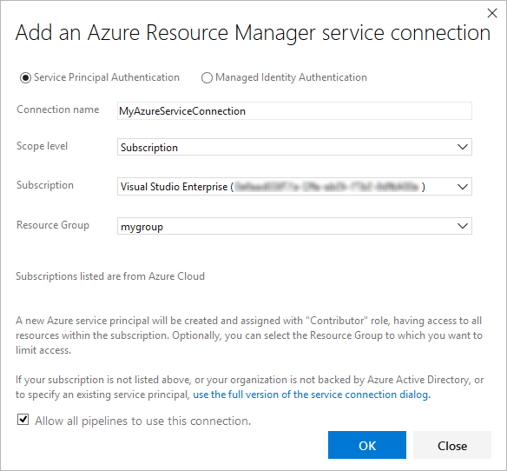

1. Decide if you want the service connection to be accessible for any pipeline by setting the **Allow all pipelines to use this connection** option. This option allows pipelines defined in YAML, which are not automatically authorized for service connections, to use this service connection. See [Use a service connection](https://docs.microsoft.com/en-us/azure/devops/pipelines/library/service-endpoints?view=azure-devops#use-connection).
2. Leave RG field blank (Packer needs to be able to create new temp RG)
3. Choose **OK** to create the connection.

For more information about Azure Resource Manager service connections, see [Connect to Microsoft Azure](https://docs.microsoft.com/en-us/azure/devops/pipelines/library/connect-to-azure?view=azure-devops). You can also create your own [custom service connections](https://docs.microsoft.com/en-us/azure/devops/extend/develop/service-endpoints?view=azure-devops).

**Create a Build Pipeline**

Create a build pipeline that downloads an Azure Martketplace image, patches it, creates a managed image using packer and stores it in an existing shared image gallery.

1. Select **Azure Pipelines**, it should automatically take you to the **Builds** page.

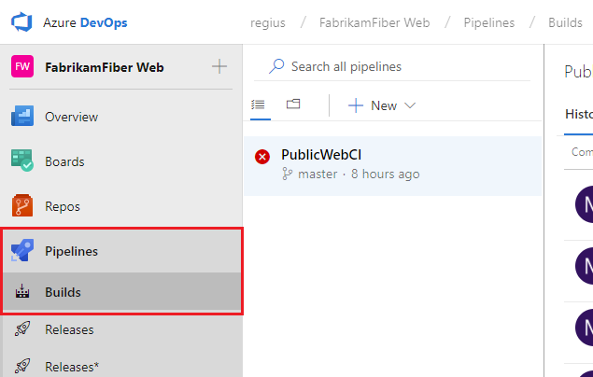

1. Create a new pipeline.

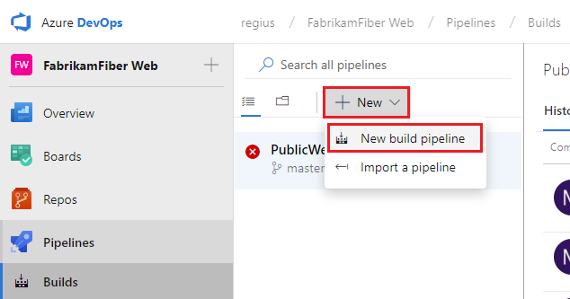

(Use classic editor for visual designer)

For new Azure DevOps accounts, this will automatically take you to the YAML pipeline creation experience. To get to the classic editor and complete this guide, you must turn off the **preview feature** for the New YAML pipeline creation experience:

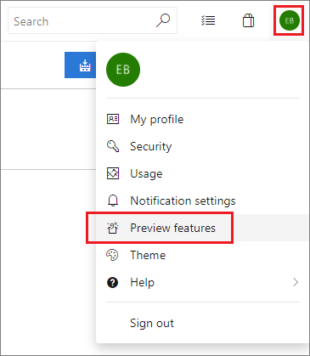

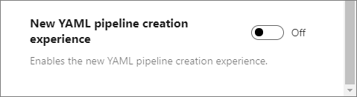

1. Make sure that the **source**, **project**, **repository**, and default **branch** match the location where the scripts are located.
2. Start with an **Empty job**.
3. On the left side, select **Pipeline** and specify whatever **Name** you want to use. For the **Agent pool**, select **Hosted VS2017**.
4. On the left side, select the plus sign **( + )** to add a task to **Job 1**. On the right side, select the **Utility** category, select the **Packer Tool Installer** task from the list, and then choose **Add**.

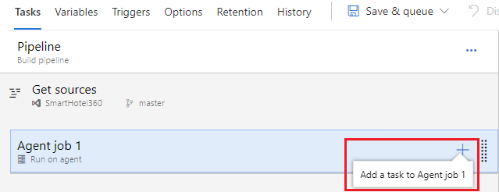

1. On the left side, select your new **Packer Tool Installer** task.
2. Fill out the configuration information below to utilize the latest version Packer.

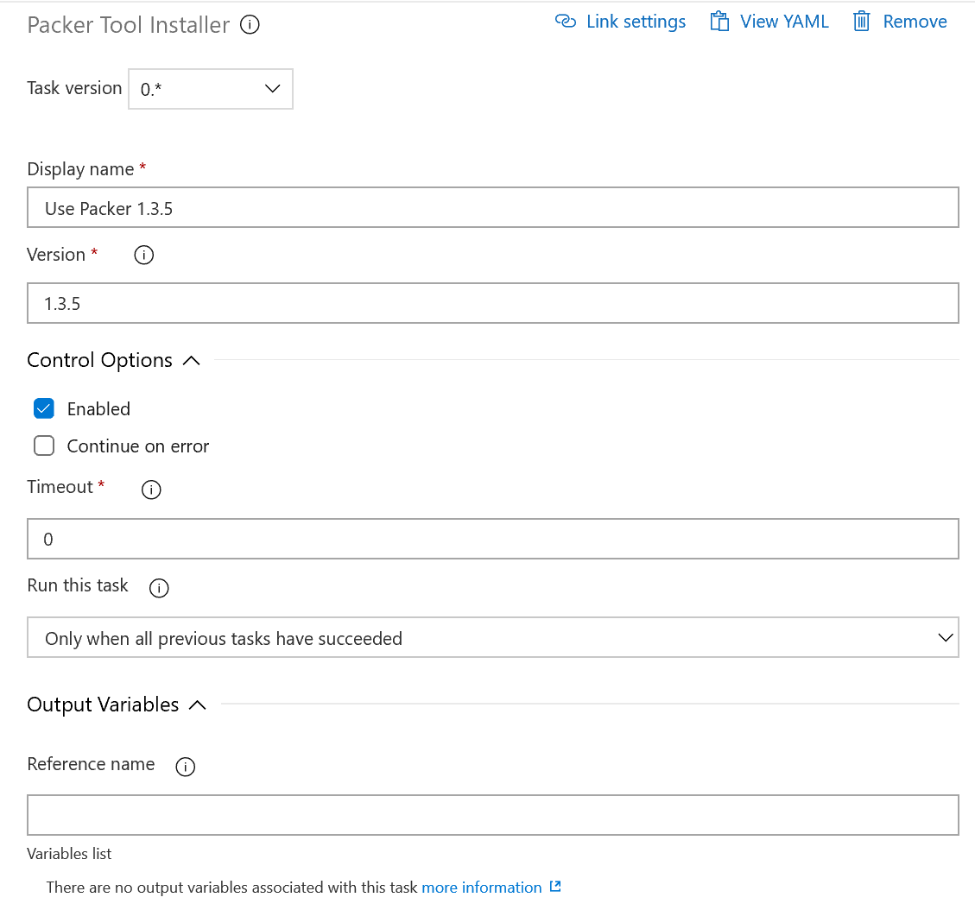

1. Select **Save**, and then select **Save**.
2. On the left side, select the plus sign **( + )** to add a task to **Job 1**. On the right side, select the **Utility** category, select the **Replace tokens** task from the list, and then choose **Add**.
3. On the left side, select your new **Replace tokens** task.
4. Fill out the configuration information as shown below.

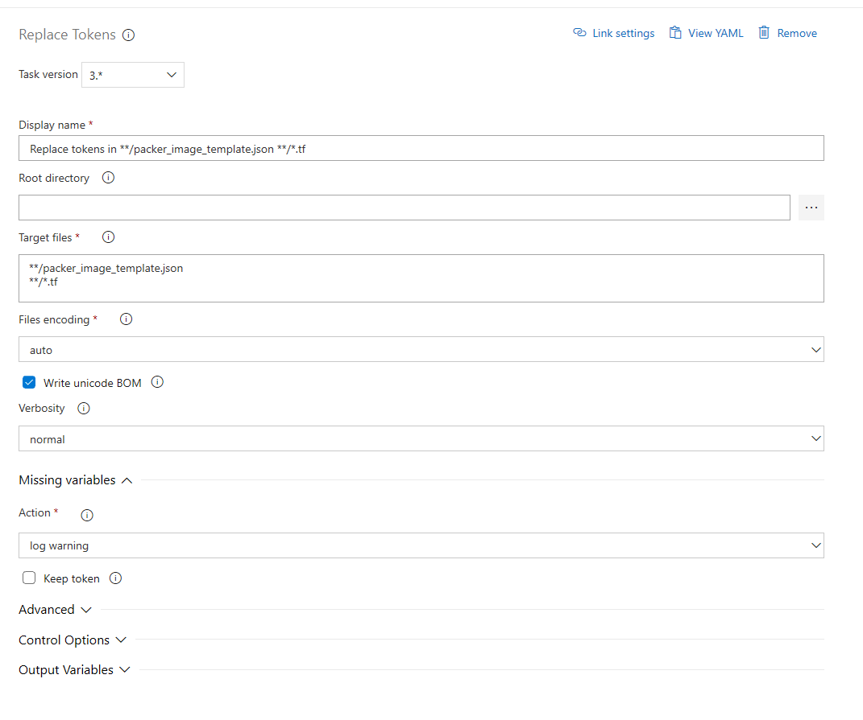

1. Select **Save**, and then select **Save**.
2. On the left side, select the plus sign **( + )** to add a task to **Job 1**. On the right side, select the **Utility** category, select the **Packer** task from the list, and then choose **Add**.
3. On the left side, select your new **Packer** task.
4. Fill out the configuration information as shown below.

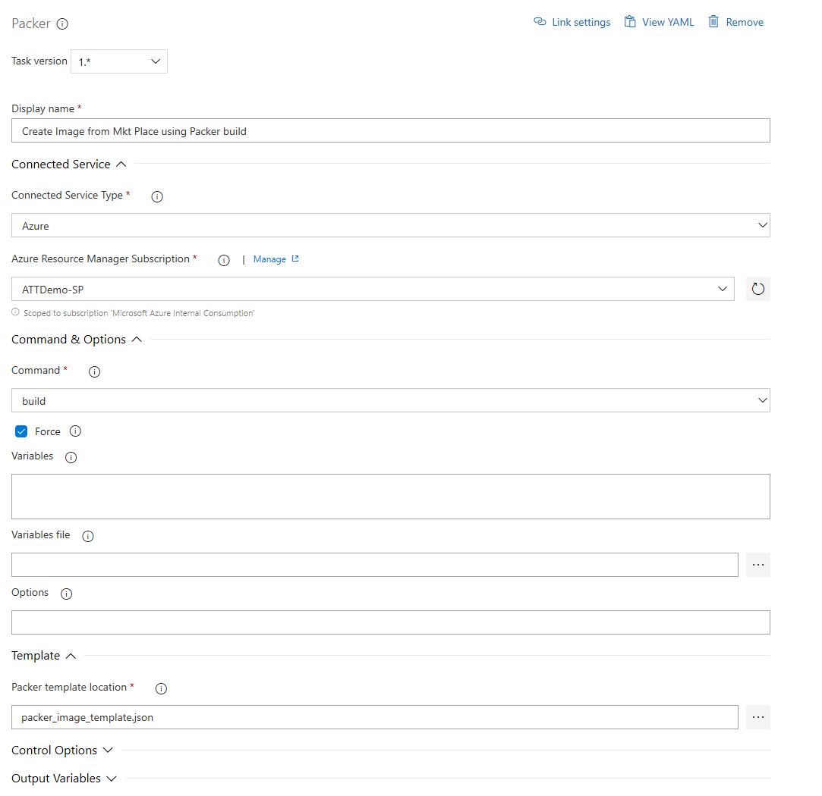

1. Select **Save**, and then select **Save**.
2. On the left side, select the plus sign **( + )** to add a task to **Job 1**. On the right side, select the **Utility** category, select the **Run Terraform** task from the list, and then choose **Add**.
3. On the left side, select your new **Run Terraform** task. Fill out the following information for Terraform init.

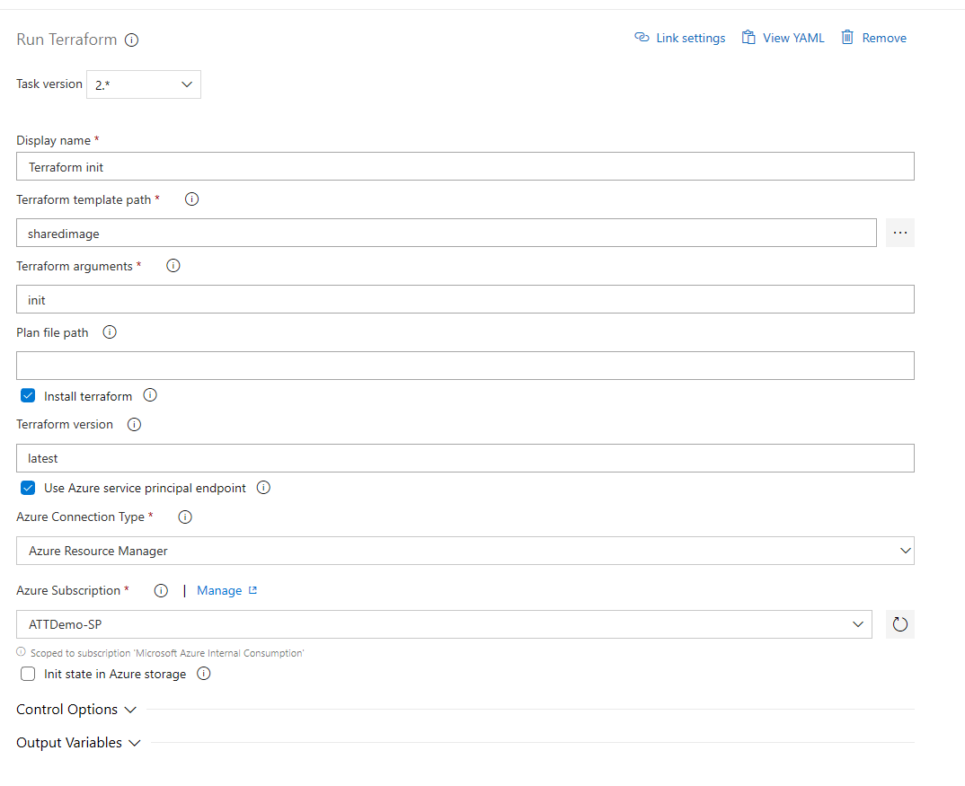 20. On the left side, select the plus sign **( + )** to add a task to **Job 1**. On the right side, select the **Utility** category, select the **Run Terraform** task from the list, and then choose **Add**.

1. On the left side, select your new **Run Terraform** task. Fill out the following information for Terraform plan.

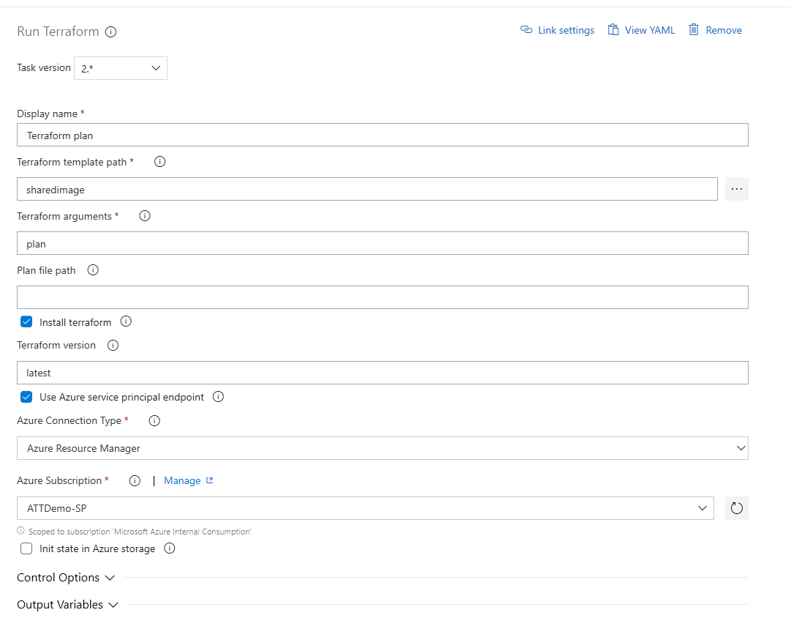

22. On the left side, select the plus sign **( + )** to add a task to **Job 1**. On the right side, select the **Utility** category, select the **Run Terraform** task from the list, and then choose **Add**.

1. On the left side, select your new **Run Terraform** task. Fill out the following information for Terraform apply.

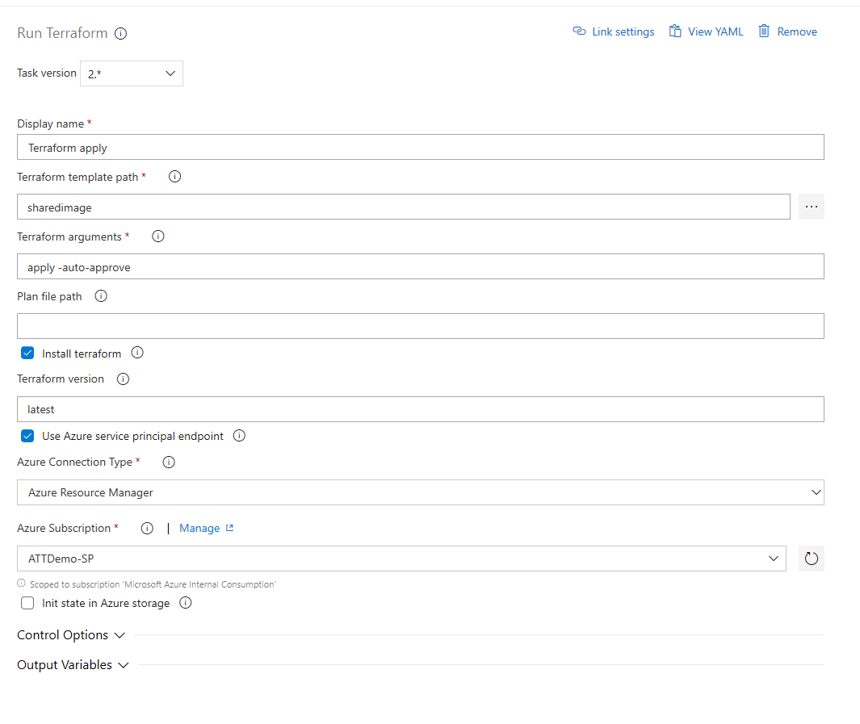

A build pipeline is the entity through which you define your automated build pipeline. In the build pipeline, you compose a set of tasks, each of which perform a step in your build. The task catalog provides a rich set of tasks for you to get started. You can also add PowerShell or shell scripts to your build pipeline.

**Pipeline Variables - Checklist**



Also see attached PackerImageBuild2-Hosted.json pipeline config export – please adjust region/resource group names and other parameters as needed.